**DATA SCIENCE & MACHINE LEARNING**

**LAB CYCLE 2**

1. Create a three dimensional array specifying float data type and print it.

import numpy as np

a=np.array([[[1,2],[3,4]],[[5,6],[7,8]]],dtype=float)

print(a)

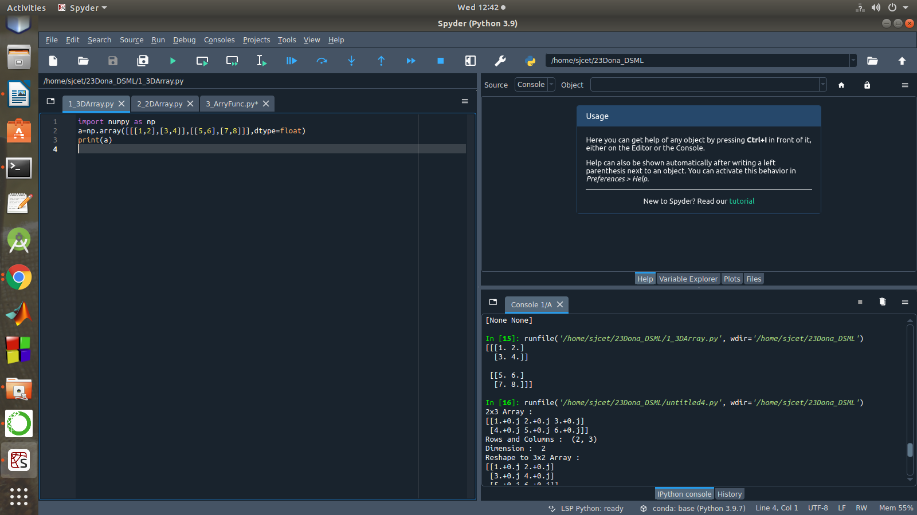

1. Create a 2 dimensional array (2X3) with elements belonging to complex data type and print it. Also display
2. the no: of rows and columns
3. dimension of an array
4. reshape the same array to 3X2

import numpy as np

a=np.array([[1,2,3],[4,5,6]],dtype=complex)

print("2x3 Array :")

print(a)

print("Rows and Columns : ",a.shape)

print("Dimension : ",a.ndim)

print("Reshape to 3x2 Array : ")

newArr=a.reshape(3,2)

print(newArr)

print("Rows and Columns : ",newArr.shape)

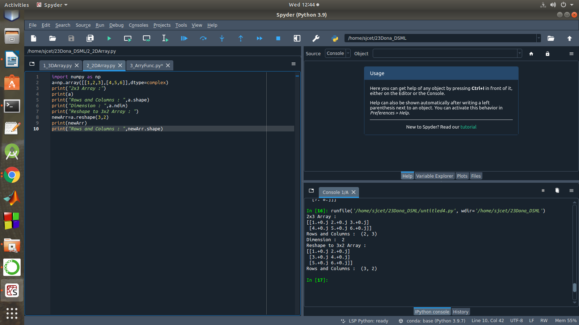

1. Familiarize with the functions to create
2. an uninitialized array
3. array with all elements as 1
4. all elements as 0

import numpy as np

print("Uninitialized Array")

a = np.full([2, 3], None)

print(a)

b = np.ones(3,dtype=int)

print("Array with all elements 1 : ",b)

c = np.zeros(3,dtype=int)

print("Array with all elements 0 : ",c)

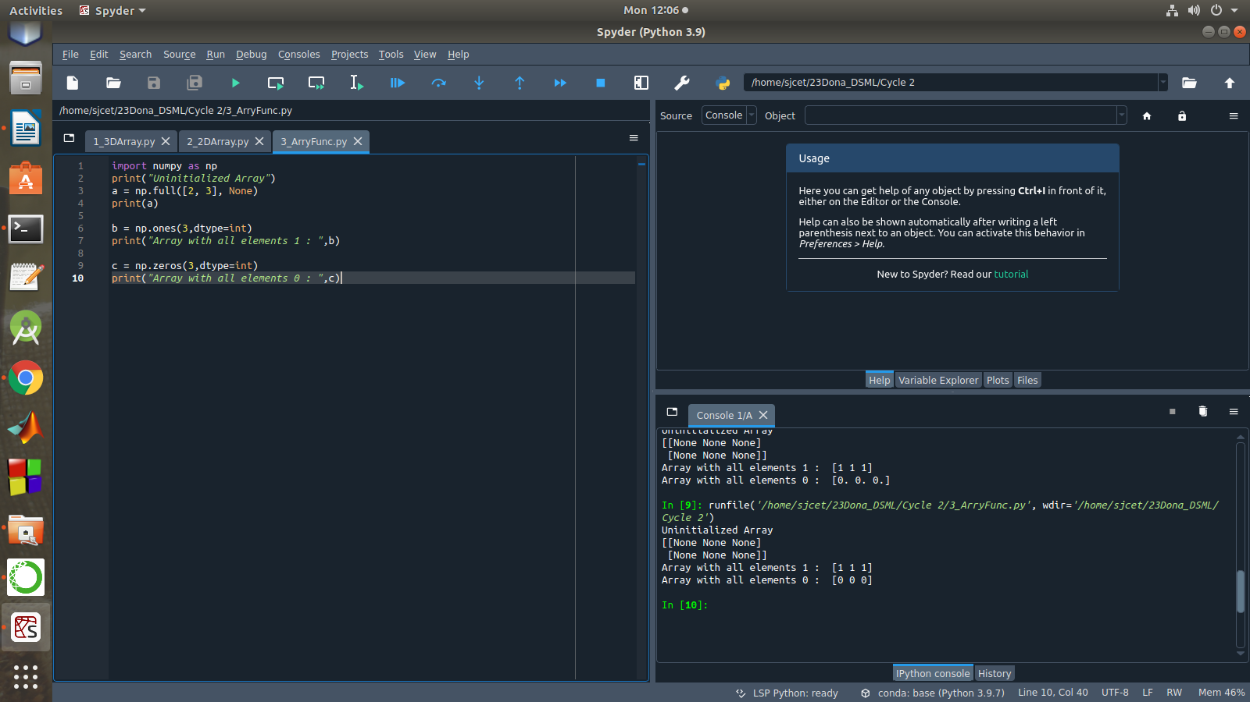

1. Create an one dimensional array using **arange** function containing 10 elements.

Display

1. First 4 elements
2. Last 6 elements
3. Elements from index 2 to 7

import numpy as np

a = np.arange(1, 11, 1)

print(a)

element1 = a[:4]

print("First 4 elements : ",element1)

element2 = a[4:]

print("Last 6 elements : ",element2)

element3 = a[2:8]

print("index 2 to 7 : ",element3)

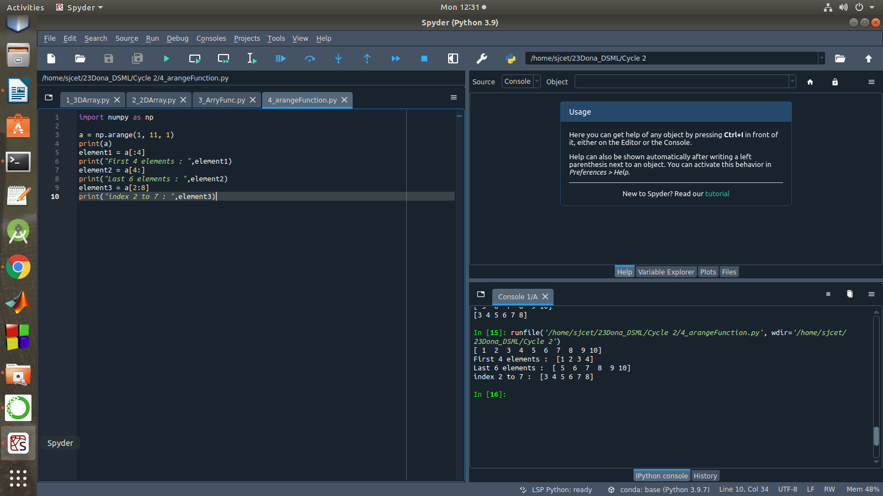

1. Create an 1D array with **arange** containing first 15 even numbers as elements
2. Elements from index 2 to 8 with step 2(also demonstrate the same using slice function)
3. Last 3 elements of the array using negative index
4. Alternate elements of the array
5. Display the last 3 alternate elements

import numpy as np

n = int(input("How many elements you want? : "))

n = 2*n

a=np.arange(0,n,2)

print("Even Array : ",a)

print("Elements from index 2 to 8 : ",a[2:9])

x = slice(2,9)

print("Elements from 2 to 8 using slice() : ",a[x])

print("Last 3 Elements:",a[-3:])

b = a[::2]

print("Alternate elements : ",b)

print("Last 3 Alternate Numbers:",b[-3:])

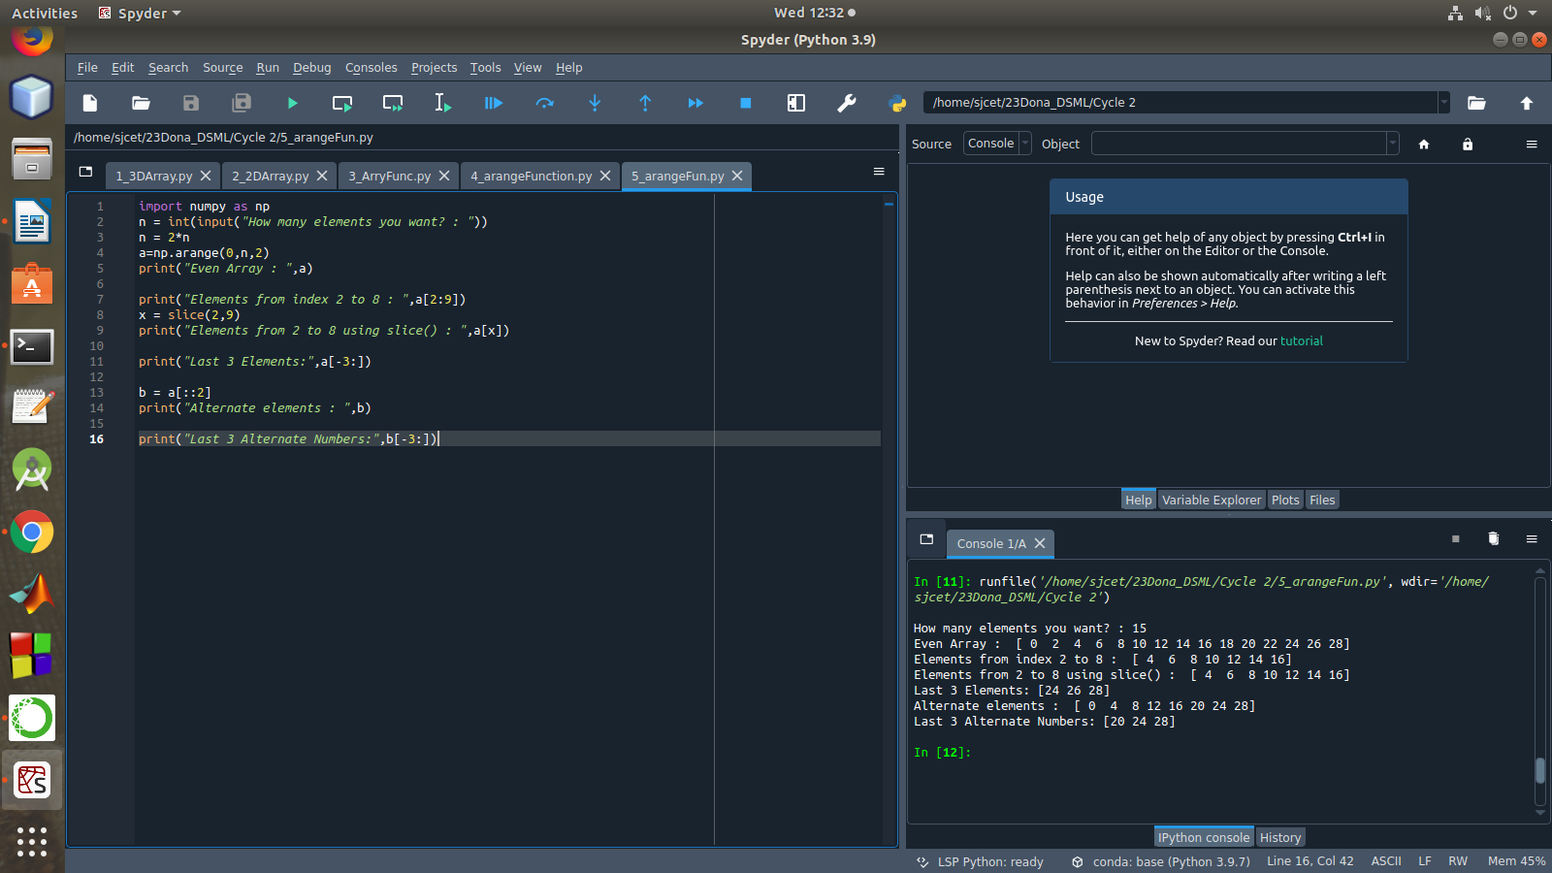

1. Create a 2 Dimensional array with 4 rows and 4 columns.
2. Display all elements excluding the first row
3. Display all elements excluding the last column
4. Display the elements of 1st and 2nd column in 2nd and 3rd row
5. Display the elements of 2nd and 3rd column
6. Display 2nd and 3rd element of 1st row
7. Display the elements from indices 4 to 10 in descending order(use –values)

import numpy as np

x = np.array([[2, 4, 6,1], [6, 8, 10,1],[1, 2, 1,1], [1, 1, 1,1]])

print("4x4 2D Array :")

print(x)

print("Display all elements excluding the first row")

print(x[1:])

print("Display all elements excluding the last column")

print(x[:, :3])

print("Display the elements of 1st & 2nd column in 2nd & 3rd row")

print(x[1:3, 0:2])

print("Display the elements of 2 nd and 3 rd column")

print(x[:, 1:3])

print("Display 2 nd and 3 rd element of 1 st row")

print(x[0,1])

print(x[0,2])

print("Display the elements from indices 4 to 10 in descending order(use-values)")

a = np.array([1,2,8,9,3,4,5,6,7])

print("Array : ",a)

array_copy = np.sort(a)[::-1]

print("Sorted Array :",array_copy)

print("Index 4 to 10 : " ,array_copy[4:10])

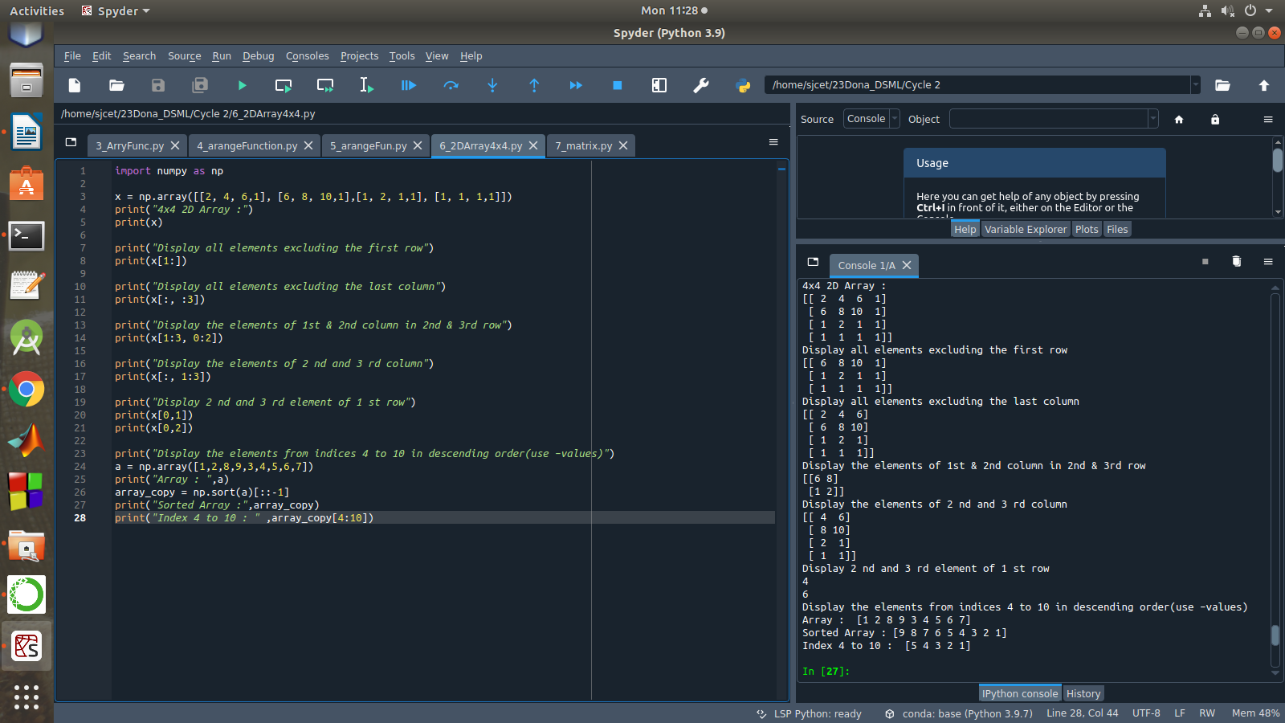

1. Create two 2D arrays using array object and
2. Add the 2 matrices and print it
3. Subtract 2 matrices
4. Multiply the individual elements of matrix
5. Divide the elements of the matrices
6. Perform matrix multiplication
7. Display transpose of the matrix
8. Sum of diagonal elements of a matrix

import numpy as np

M1 = np.array([[9, 2], [5, 8]])

M2 = np.array([[3, 4], [1, 4]])

print("First matrix \n ",M1)

print("Second matrix \n ",M2)

add = M1 + M2

print("Matrix addition\n",add)

sub = M1 - M2

print("Matrix Substract\n",sub)

mul = M1 * M2

print("Multiply the individual elements of matrix\n",mul)

div = M1 / M2

print("Divide the elements of the matrices\n",div)

M3 = M1.dot(M2)

print("matrix multiplication \n",M3)

tr = M1.transpose()

print("Transpose of the First matrix\n",tr)

print("Sum of diagonal elements of first matrix")

print(np.trace(M1))

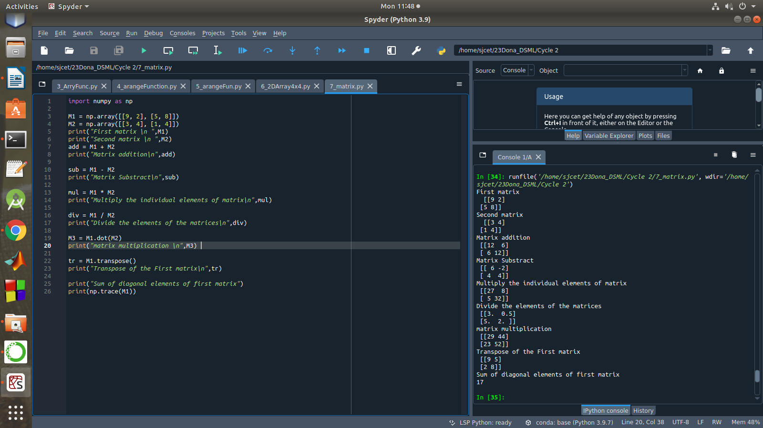

1. Demonstrate the use of insert() function in 1D and 2D array.

import numpy as np

arr1 = np.arange(10, 16)

print("1D ARRAY ")

print("The array is: ", arr1)

obj = 2

value = 40

arr = np.insert(arr1, obj, value, axis=None)

print("After inserting the new array is: \n",arr)

print("Shape of the new array is : ", np.shape(arr))

print("2D ARRAY ")

arr1 = np.array([(1, 2, 3), (4, 5, 6), (7, 8, 9), (50, 51, 52)])

print("The array is: \n",arr1)

print("The shape of the array is: ", np.shape(arr1))

a = np.insert(arr1, 1, [[50], [100], ], axis=0)

print("New array is : \n",a)

print("Shape of the array is: ", np.shape(a))

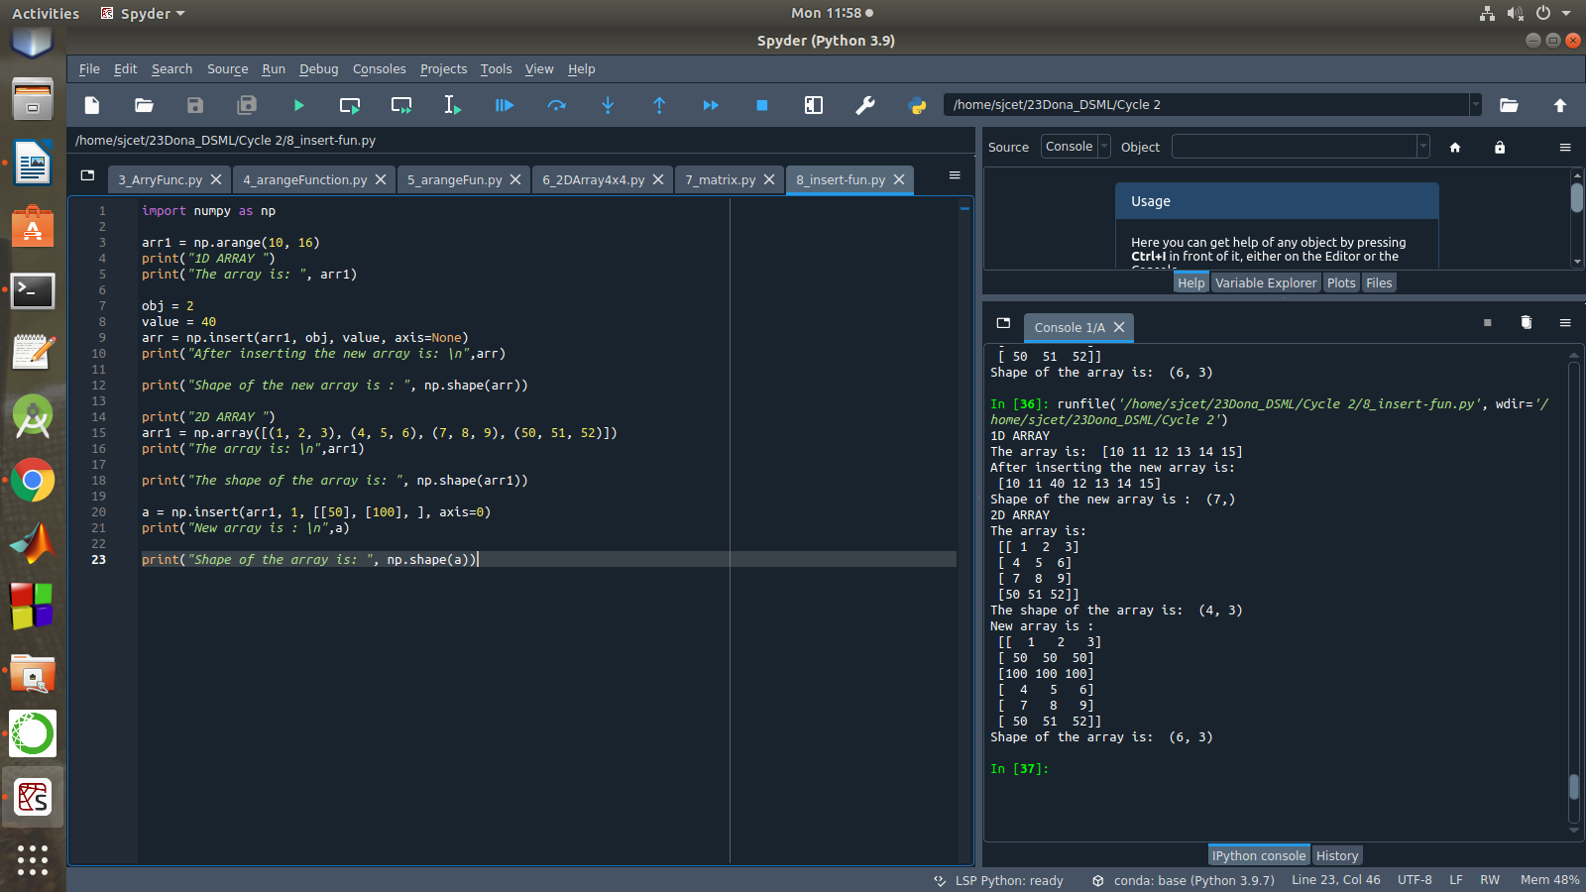

1. Demonstrate the use of diag() function in 1D and 2D array.

import numpy as np

a= np.array([[3,6,7,8]])

b=np.array([[3,6,8,7], [4,2,1,0],[3,1,3,3],[1,1,2,2]])

print("1d array : ",a)

print("2D array \n",b)

print("diag() function")

x=np.diag(a)

y=np.diag(b)

print(x)

print(y)

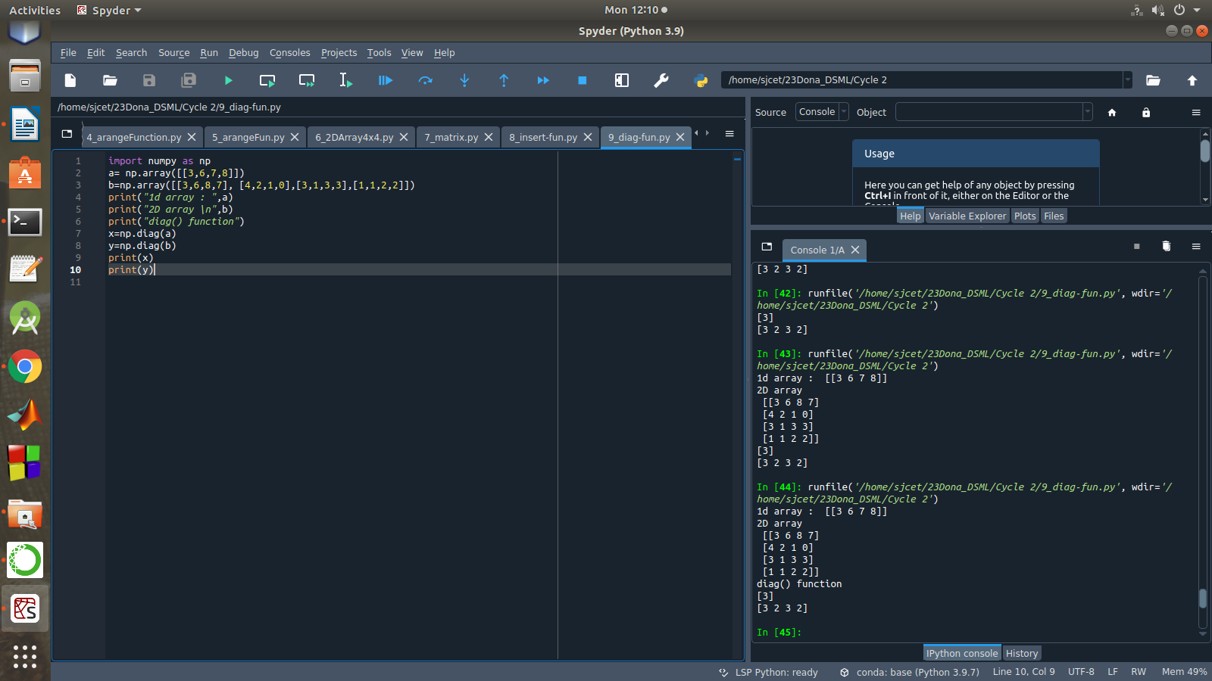

1. Demonstarte the use of append() function in 1D and 2D array.

import numpy as np

a = np.array([1,2,3])

b = np.array([[1,2,3],[4,5,6]])

print("First array:\n",a)

print("Second array\n",b)

print ("Append elements to array:")

print (np.append(a, [7,8,9]))

print (np.append(b, [7,8,9]))

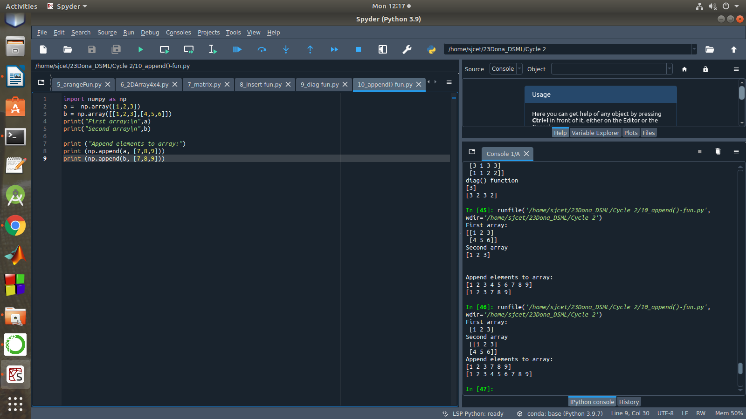

1. Demonstarte the use of sum() function in 1D and 2D array.

import numpy as np

a=np.array([4,5])

b=np.array([[1,2,3],[4,5,6]])

print("1D array\n",a)

print("2D array\n",b)

print("sum() function")

asum=np.sum(a)

print(asum)

bsum=np.sum(b)

print(bsum)

